## Lab 07 - Histogram Equalization

In this exercise you try to improve the contrast of an image by doing histogram equalization.

Consider the example below.

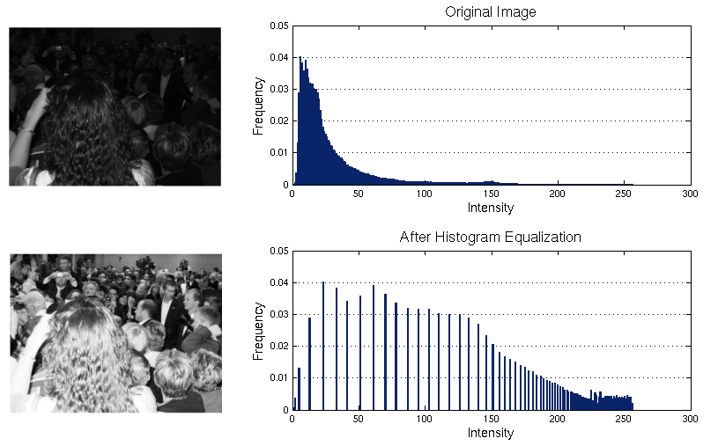

1. Write a program that shows the histogram for a given image. For displaying the histogram, you may use Matplotlib. The following link might be helpful in this regard. <https://bespokeblog.wordpress.com/2011/07/11/basic-data-plotting-with-matplotlib-part-3-histograms/>
2. Write a program that equalizes the histogram of a given image. Consider the formula,

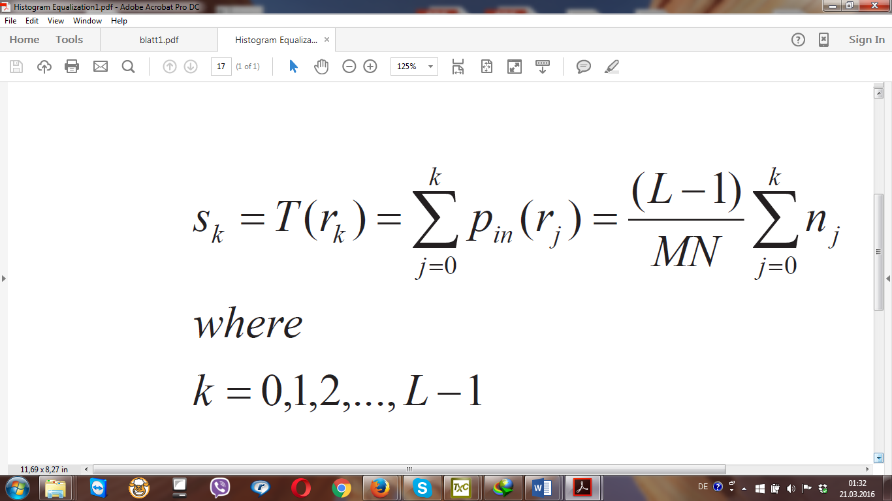

c) Show the histograms before and after equalization. Again consult Matplotlib. Opencv can also be an option.

d) Does the equalized histogram has a uniform distribution?

**Some important points about the exercise.**

1. You should apply histogram equalization on any Greyscale image.  
2. You should not use the builtin histogram equalization method available in matplotlib or opencv. You can use these packages only for displaying histograms.  
3. You should implement the formula mentioned in the exercise sheet to implement histogram equalization.